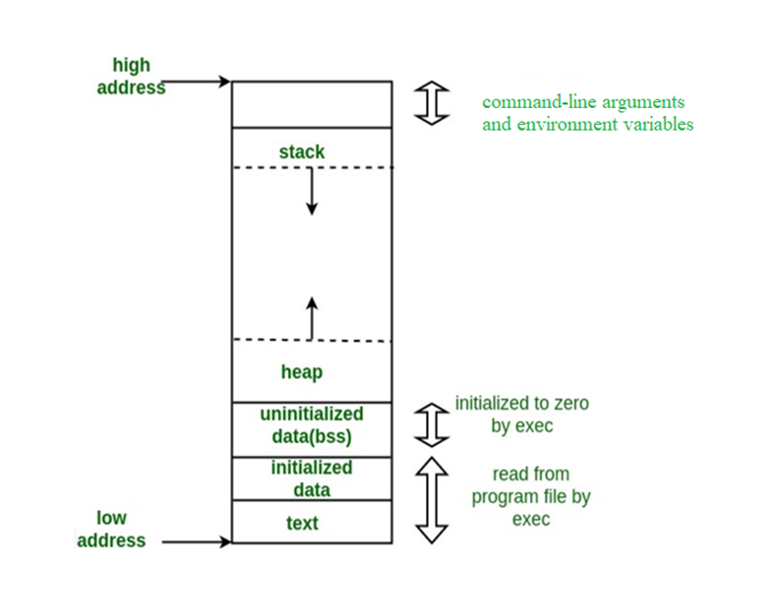

function call local variable within the function

Dynamic Memory rest all is static memory

static and global variables ( data )

stores instructions

( code )

Free pool of memory

Static Memory doesn’t grow while runing the program.

Dynamic memory grow while the runtime. Heap is used for dynamic memory allocation.

STACK: Is an implementation of stack data structure.

HEAP: Is not an implementation of heap data strcuture.

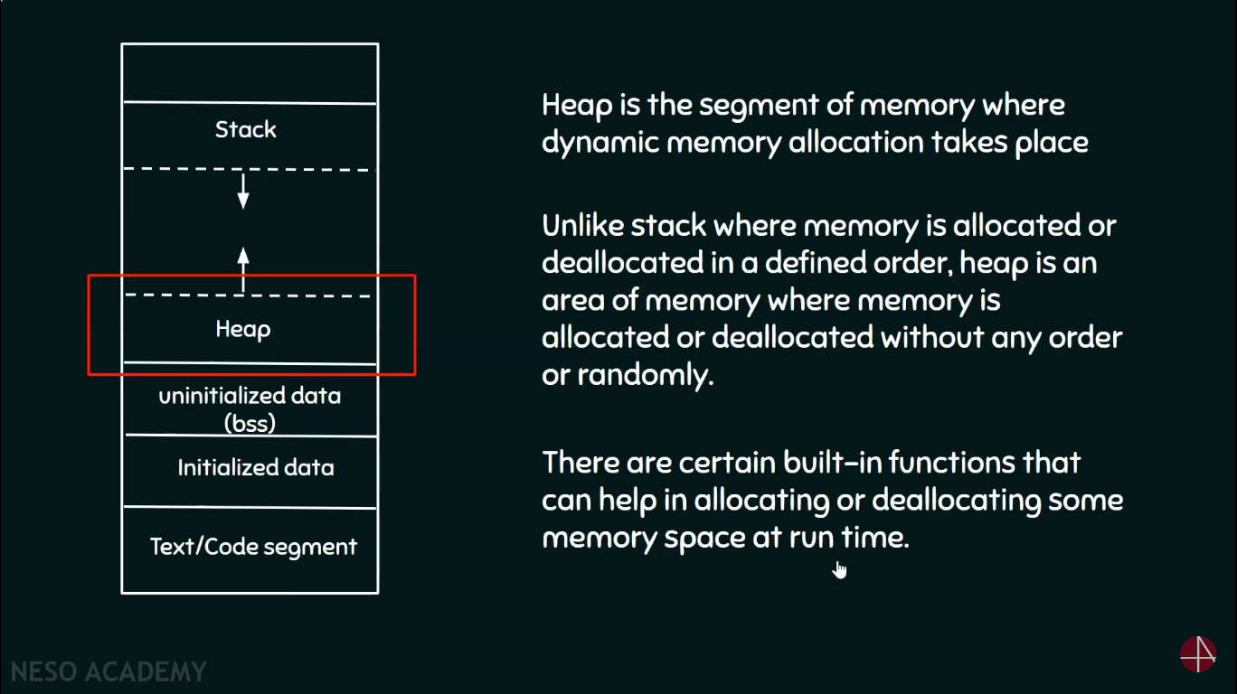

Functions such as

in C - malloc, calloc, free

in c++ - new, delete

in python - constructor ex list(), set()